1. Sign up for a free Jira account, create a new project named 'Food Delivery App QA', and add a sample bug titled 'Order status not updating after payment'.
Ans:
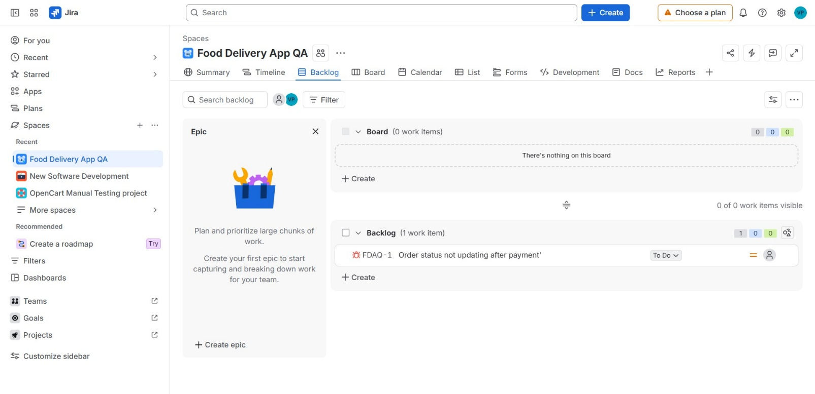

2. Fill out a defect report in Jira for a bug you found in any app you use daily (like Zomato, Flipkart, or Paytm), using all main fields: Summary, Description, Steps to Reproduce, Expected Result, Actual Result, Severity, and Priority.<br><br><em><strong>Hint:</strong> Use a real or imagined bug, but make the details specific and realistic.</em>
Ans:
Here's a realistic Jira defect report for a bug I've hit in Zomato:
Project: Zomato – Android App
Issue Type: Bug
Reporter: QA / End User
Summary:
Scheduled delivery time silently resets to "Deliver Now" after editing cart quantity
Description:
When a user schedules an order for a later time slot (e.g., "Deliver at 8:00 PM") and then modifies the cart such as removing an item and re-adding it, or changing item quantity the app silently reverts the delivery preference back to "Deliver Now" without any warning or confirmation prompt. The user is not notified of this change, so if they don't scroll back up to check the delivery time before placing the order, the food gets dispatched immediately instead of at the scheduled time.
Steps to Reproduce:
- Open the Zomato app and add items from any restaurant to the cart.
- On the checkout screen, tap "Schedule for later" and select a delivery slot (e.g., 3 hours from now).
- Go back to the cart and either remove one item or change the quantity of an existing item.
- Return to the checkout screen and place the order without re-checking the delivery time field.
- Observe the order confirmation and tracking screen.
Expected Result:
The previously selected scheduled delivery time (e.g., 8:00 PM) should persist even after cart items are modified, unless the user explicitly changes it. At minimum, the app should show a prompt like "Your scheduled time was reset — please confirm" if it needs to reset.
Actual Result:
The delivery preference silently reverts to "Deliver Now," and the order is placed for immediate delivery. No toast, dialog, or visual indicator alerts the user to this change before order placement.
Severity: Major (core ordering flow behaves incorrectly and can lead to unwanted immediate charges/delivery)
Priority: High (directly impacts user trust and can cause real-world inconvenience — e.g., no one home to receive an unscheduled early delivery)
Environment:
- App Version: 20.3.2
- OS: Android 14
- Device: Redmi Note 12
- Network: Wi-Fi
Attachments: Screen recording showing cart edit → scheduled time reverting (would be attached in actual ticket)

3. Given these three bugs found in a movie ticket booking app: (1) Payment fails for UPI, (2) Movie poster image is blurry, (3) App crashes if you book more than 10 tickets at once — classify each bug as High/Medium/Low Severity and High/Medium/Low Priority, and justify your choices.
Ans:
Here’s a practical classification based on user impact, business impact, and urgency:
Bug | Severity | Priority | Justification
1. Payment fails for UPI | High | High | UPI is a major payment method. A failure prevents users from completing bookings, directly affecting revenue and customer experience. It should be fixed urgently.
2. Movie poster image is blurry | Low | Low | The issue is mainly visual and does not prevent users from searching for movies or booking tickets. It has limited functional impact, so it can be addressed later.
3. App crashes when booking more than 10 tickets | High | Medium | A crash is a serious functional defect, especially for group bookings. However, it affects a narrower scenario than a general payment failure, so its priority can be slightly lower depending on usage data.
Summary
High Severity / High Priority: Payment fails for UPI
Low Severity / Low Priority: Blurry movie poster
High Severity / Medium Priority: App crashes for more than 10 tickets
Note: Severity describes how badly the bug affects the system, while priority describes how urgently the team should fix it.

4. Draw the complete bug life cycle for a typical defect in Jira, labeling each stage (for example: New, Assigned, In Progress, Fixed, Retest, Closed, Reopened) and describing what happens at each step.<br><br><em><strong>Hint:</strong> You can use a simple flowchart tool or draw and scan a diagram, but your answer must include both the diagram and brief descriptions.</em>
Ans:
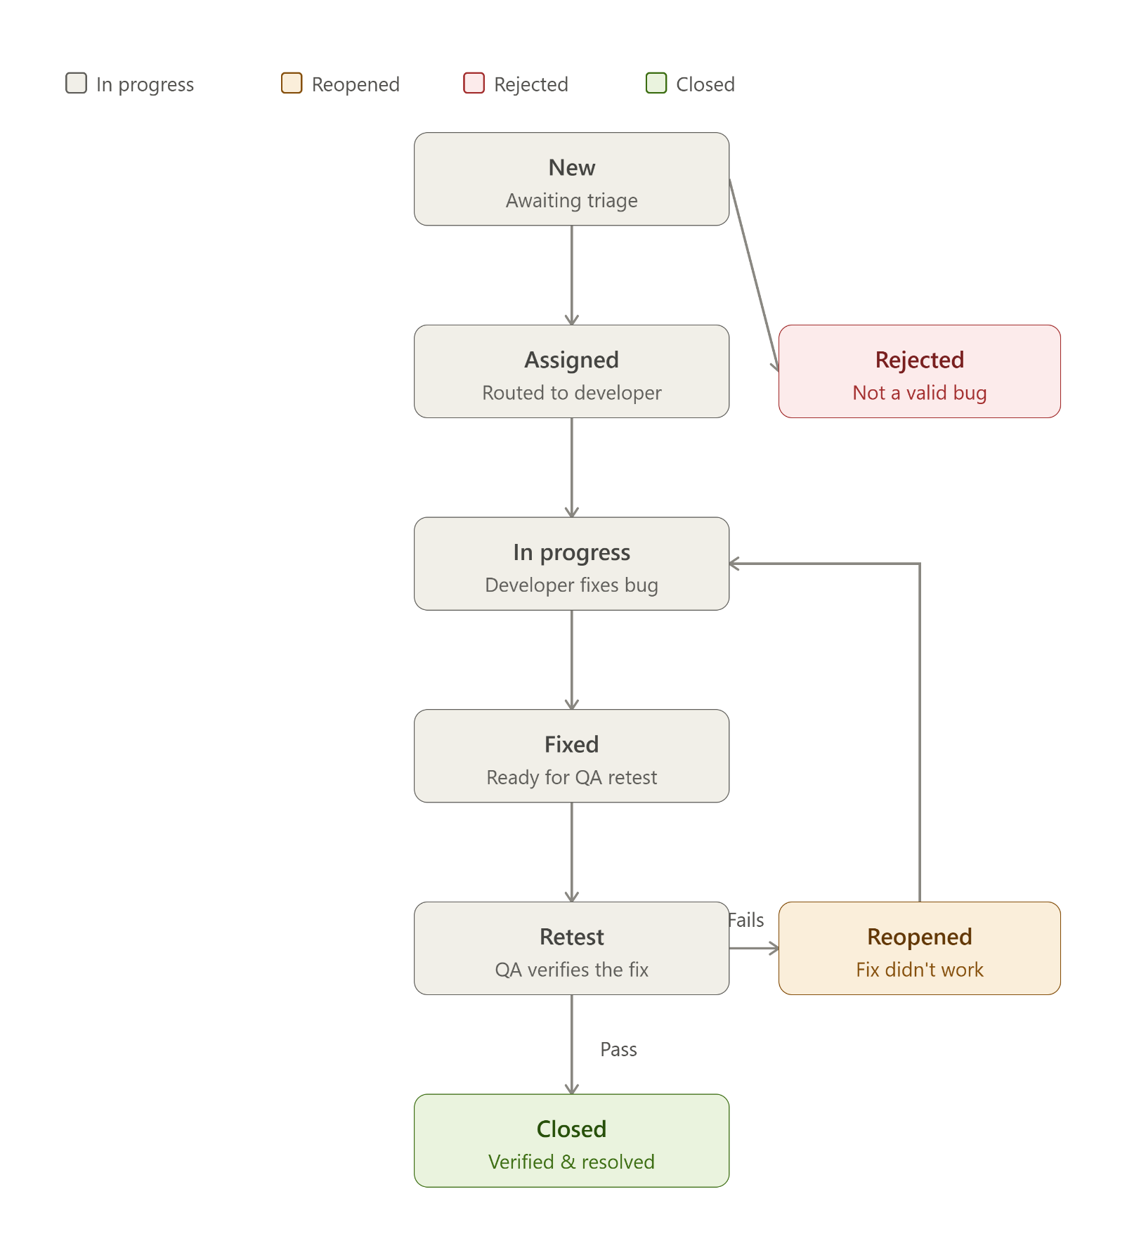
Here's what happens at each stage of the diagram:
1. New — QA or a user logs the defect with steps, screenshots, and environment details. It sits untriaged until a lead reviews it.
2. Assigned — The issue is triaged and routed to a specific developer (or dev team) based on the module affected.
3. In Progress — The developer reproduces the issue, investigates the root cause, and writes the fix in a branch.
4. Fixed — The developer marks the bug as fixed once the code is merged/deployed to the QA/staging build, handing it back for verification.
5. Retest — QA re-runs the original steps to reproduce (plus checks for regressions) against the fix.
- If it passes → moves to Closed.
- If it fails → moves to Reopened, which loops back into In Progress for another attempt.
6. Closed — QA confirms the fix works as expected; no further action needed.
Rejected (side branch off New) — Triage can also end a bug early if it's a duplicate, not reproducible, or working as intended — skipping the rest of the flow entirely.
Reopened — Not a dead end but a loop: it sends the bug straight back to development rather than starting a new ticket, which is why it's drawn as a return arrow rather than a new terminal state.

5. Download a sample defect template from the internet (or use a template provided in class), and fill it out for a bug you noticed in any social media app (like Instagram or WhatsApp), making sure to include Severity and Priority fields.
Ans:

Sample Defect Report - Social Media App
Standard defect template completed for an imagined Instagram-style bug
Defect ID | SM-001
Application | Instagram-style Social Media App
Module | Direct Messages (DM)
Summary | Image message fails to send when the user switches from Wi-Fi to mobile data
Description | When a user attaches an image in a direct message and changes the network connection from Wi-Fi to mobile data before pressing Send, the message remains stuck in Sending and does not complete unless the chat is reopened or the message is resent.
Steps to Reproduce | 1. Log in to the app.  2. Open any Direct Message conversation.  3. Attach a JPG image from the device gallery.  4. While the image is uploading, switch from Wi-Fi to mobile data.  5. Wait 10 seconds and observe the message status.
Expected Result | The app should detect the network change, resume or restart the upload, and send the image successfully. The message should eventually display as Sent.
Actual Result | The image message remains stuck on Sending and does not complete. No clear error message or retry option is shown.
Severity | Medium - Image sharing is unavailable in this scenario, but users can still send text messages and use other app features.
Priority | High - The issue affects a common messaging action and should be fixed promptly to avoid failed communications and user frustration.
Environment | Android 14; App version 325.x; Wi-Fi to 5G mobile-data switch
Status | New
Note: This is an imagined defect created for a testing assignment; it is not a verified defect in Instagram or another production app.

